Individual Cell Based Study of Run 9 FMS Data
Note by S. Heppelmann 11 January 2010
Contents
1) Cell Class 1
A) Basic Cell Data Members 2
B) Calibration Data Structures 2
C) Histograms From Analysis 4
D) Tree of variables 4
E) Retrieving Raw ADC data. 5
F) TObjArray of Cell Objects 6
2) Re-reconstruction 8
3) Examples 8

Calibration of the FMS calorimeter requires an analysis that emphasizes the study of raw and reconstructed FMS data that is related to a particular FMS cell. A “Cell” class has been written the contains information about the events that produce pairs of photons (pi0 candidates) that produce substantial energy in “this” particular cell.

1) Cell Class
A “Cell” class has been written to represent a particular cell in the FMS. A cell is defined in the standard scheme with specification of

EW=1-East / 2-West
NSTB=1- North Large /2-South Large/3-North Small /4-South Small
RunNum= run number (used to indicate data format) Note a cell describes data from many runs
row = (1-24 for small cells) (1-34 for large cells)
col = (1-12) for small cells) (1-17 for large cells)
p_geom = structure containing geometry information
gain = structure containing gain information
gcor= structure containing gain correction information (this changes for calibration looping)

Cell* pcell=new Cell(EW,NSTB,row,col,RunNum,p_geom,&gain,&gcor);

A) Basic Cell Data Members
Some of the basic class data members that define the location of the cell (cell center) are:
Int_t Iew ,Instb,Row1,Col1,Rnum;
float_t xLocal,yLocal;
float_t xGlobal,yGlobal;
float_t Eta;
float_t Phi;

Where

Iew=2 for West
Instb=1-4 ( referring to N-large,S-large,N-small,S-small).
X_Local = cell center x coordinate in detector local system
Y_Local= cell center y coordinate in detector local system
X_Global= center in STAR Global coordinate system
Y_Global= center in STAR Global coordinate system

B) Calibration Data Structures
There are the basic data that define cell gain calibration and location. When the Cell structure is streamed to a root file, the calibration structures are streamed into the file at this time.

CalibStr* fpdcorr; the gain correction structure used for this round or reconstruction
CalibStr* fpdgain; the gain structure used for this round of reconstruction
Geom* p_Geom; the geometry structure used for this round of reconstruction
Float_t gcorr; gaincorr used for this cell
Float_t gain; gain used for this cell

The basic looping for calibration would update fpdcorr. It is important to remember that the text file from which fpdcorr was created, named ( fpdcorr->filename) only served to define this structure at creation time. After streaming to a root file, the structure is located in the root file and is no longer connected to the original text file.

If at some time we want to output a current copy of the text file, the method is

Fpdcorr->UpdateFile(int n)

The new path will (by default) be the old path with V_[n] appended to the filename. The bookkeeping after this step is to be done externally.

For a Cell instance

Cell* c

We can access the gain correction for a specific channel with
Float_t value =c->fpdcorr->GetValue(Iew,Instb,Row-1,Col-1).

or we can reset the value

c->fpdcorr->SetValue(Iew,Instb,Row-1,Col-1,newvalue)

Note: When an TObjArray of Cell structures is written to a root file, a single copy of the calibration files will be maintained in that root file. A change in one cell, written to file, would imply a change for all cells.

C) Histograms From Analysis
After secondary analysis of FMS data (reading OFile data) histograms are made for events that have a signal in “this” cell. Some of them are.
TH1F* p_Mcell; Two photon Mass distribution
TH2F* p_MvsZ; Two photon Mass vs Z
TH1F* p_EphXY; Two photon energy (E1+E2)
TH1D* p_adc; ADC distribution
TH2F* p_MvsD; Mass vs two photon separation
TH2F* p_MvsE; Mass vs Energy
TH2F* p_MvsY; Mass vs Pseudorapidity

TH3F* p_dxdyM; photon dx vs photon dy vs Mass (dx,dy are the distances to “other” photon in units of cell size”)
TH3F* p_dxdyE; photon dx vs photon dy vs pair energy. (dx,dy are the distances to “other” photon in units of cell size”)

TH3F* p_dxdyER; photon dx vs photon dy vs energy ratio. (dx,dy are the distances to “other” photon in units of cell size”)

D) Tree of variables
An analysis of data that goes beyond the simple histogram is provided with a TTree of basic data variables. The tree runs over all events that were selected to be associated with this cell.
An object in the Cell class is then
TTree* CellD;

With branches locally linked to an object of class tpCellDat shown further below

tpCellDat celldat;

Each call to CellD->GetEntry( number) will refill celldat for event entry “number”.

class tpCellDat : public TObject
{
public:
tpCellDat(){};
Float_t Mcell;
Float_t Epair;
Float_t Ypair;
Float_t E1; Float_t E2;
Float_t X1;
Float_t X2;
Float_t Y1;
Float_t Y2;
unsigned SavedHits[100];
Int_t nSavedHits;
Int_t NSTB;
private:
ClassDef(tpCellDat,1)
};

Some Cell methods that manipulate the TTree object CellD are listed below:

void InitTree(char*);
void InitBranches();
void CreateBranches();
void FillTree(tpCellDat);

E) Retrieving Raw ADC data.
The variables called SavedHits is very significant. It contains the re-packed ADC raw data for selected events (dumped in first pass reconstruction for clusters or hits that have energy greater than some threshold energy).
For an instance of a Cell class
Cell* c;
For example, we can refer to the 20’th event in the “selected event” tree by
c->CellD->GetEntry(20);
We can then access the ADC data with the use of the method
TObjArray* CellHitList();
For example, the first ADC hit for the 20’th event would be:
(CellHit*) ( c->CellHitList()->First())
where the CellHit class is defined below.
class CellHit : public TObject
{
public:
CellHit(){};
CellHit(unsigned int );
unsigned int packed;
Int_t EW;
Int_t NSTB;
Int_t Row;
Int_t Col;
Int_t ADC;
private:
ClassDef(CellHit,1)
};

F) TObjArray of Cell Objects

The way the Cell Class is intended to be used is for a representation of a data set sorted by impact on individual Cells.
A root file, perhaps named “Output.root” can contain a TObjArray perhaps called Mycells.
This file will likely be >100 Mbytes in length. Mycells may contain a Cell entry for each FMS cell. My convention is to name each cell (Each Cell derives from TObject and so has a name) something like
“Cellr10_c11_2”
for a cell in Small-North (NSTB-1=2), (Row -1)=10 and (Col-1)=11
Access to the cell can be obtained like this.
> root Output.root
root[1]: gSystem->Load("../../Fpdchan.so");
root[2]: Cell* c=(Cell*) Mycells->FindObject(“Cellr10_c11_2”);
root[3]: c->InitBranches();
root[4]: c->CellD->GetEntry(20); //get 20’th event
root[5]: c-> DrawFMSADC(3,true); // display the adc distribution for Small-North for event 20

2) Re-reconstruction
The value of the cell class is that we have reorganized information (input and output) after initial reconstruction. It is possible to observe the impact of calibration on reconstruction by plotting two photon mass distributions or two photon energy distributions. This analysis would be only for two photon events that impact the particular cell of interest.
After evaluation based on the wide range of information available in the “Cell” class we can change the calibration constants. We then can re-reconstruct only those events that impact this cell. This allows calibration with more rapid looping on smaller subsets of data to determine the effect of a change on the cell of interest.
An example of using the Yiqun class to re-reconstruct data is shown below:
root[1]: gSystem->Load("../../Fpdchan.so");
root[2]: Cell* c=(Cell*) Mycells->FindObject(“Cellr10_c11_2”);
root[3]: c->InitBranches();
root[4]: c->CellD->GetEntry(20); //get 20’th event
root[5]:TMatrix Emat=c->FillFMSEnergy(dt+1); // Get energies from ADC data for 20’th event
root[6]: Yiqun rec(&Emat, c->p_Geom, c->fpdgain, c->fpdcorr,2,3);

The instance rec contains reconstruction results that reflects any changes in c-> fpdcorr that may have been made.

3) Examples
The whole point of the Cell class is to facilitate looping over sequences of :
- Data analysis of raw data (trigger data) to produce summary files called “OFiles.root”.
- Analysis of output “OFIles.root” to produce a “TObjArray” of “Cell” objects.
- Analysis of “Cell” objects to determine new correction factors (stored in the fpdcor structure and saved in a text file like “fmscorr.txt”).
Traditionally the looping involves calculation of the ratio of the pi0 mass peak to the nominal value and changing the gain of a particular cell to move the pi0 mass in the right direction.

The problem with this process for FMS calibration analysis has three components.
- After calibration of FMS data, the fitted pi0 peak location has been very dependent upon on pi0 energy. Slopes ranging from 0.3 %/GeV to 1%/GeV have been seen. (This compares to less than 0.1 %/GeV in run 6 FPD data.)
- Calibration algorithms to this point get the pi0 right only at some particular energy.
The Trigger threshold for most run 9 FMS data is very high so for some channels there are very vew triggered pi0’s. The uniformity of the trigger threshold is better than than for run 8 FMS data but still variable. The consequence is that calibration pi0 data come from either low energy pi0’s (5-20 GeV) that are not part of the trigger or high energy pi0’s that are triggering the FMS (50-100 GeV for small cells).
Below we look at several cells at pseudo-rapidity of approximately 3.65, the same as the rapidity of the Run 6 FPD. In each case we show
- on the left: fitted 2 photon mass vs fitted 2 photon energy
- on the right: the two photon energy distribution
It is noted that the slopes of the mass peak vs energy plots vary from about 0.3 %/GeV to about 1.5 %/GeV.

Row-6 Col-8 Small North
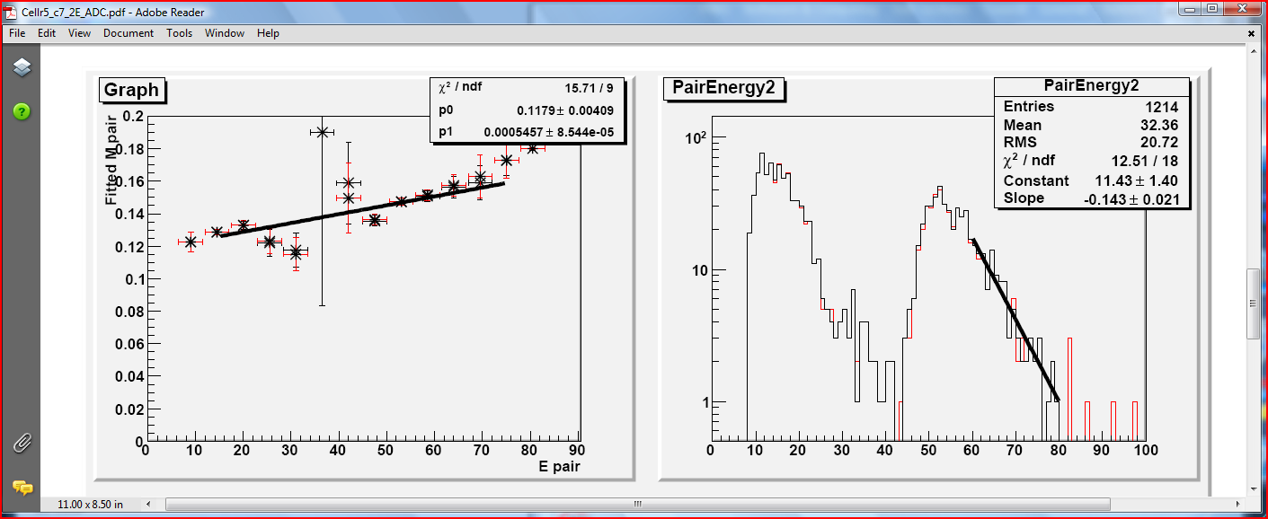

Row-6 Col-8 Small South
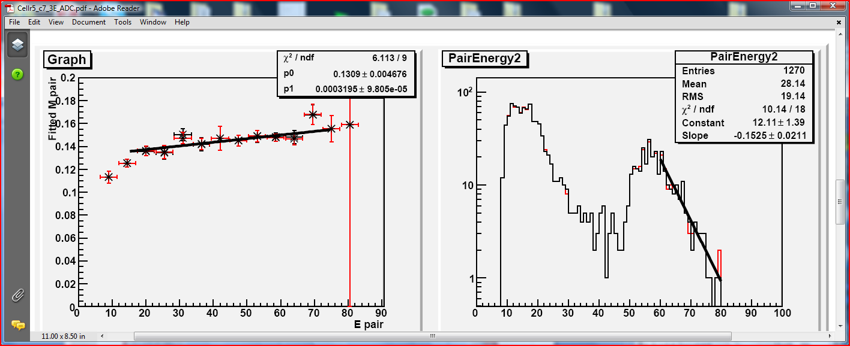

Row-19 Col-8 Small North
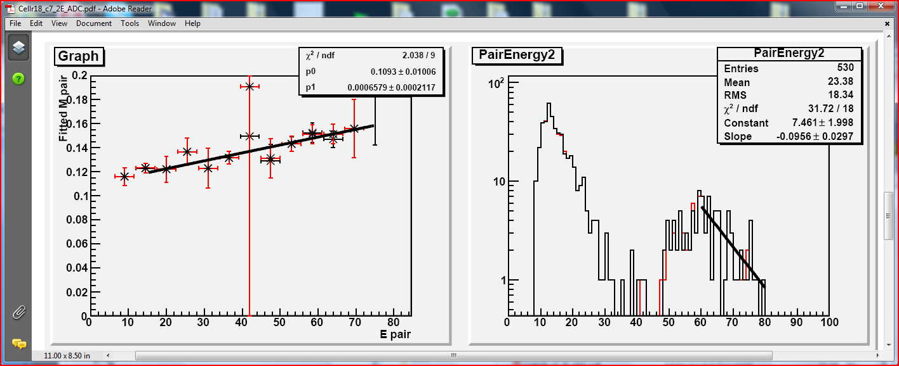
Row-19 Col-8 Small South
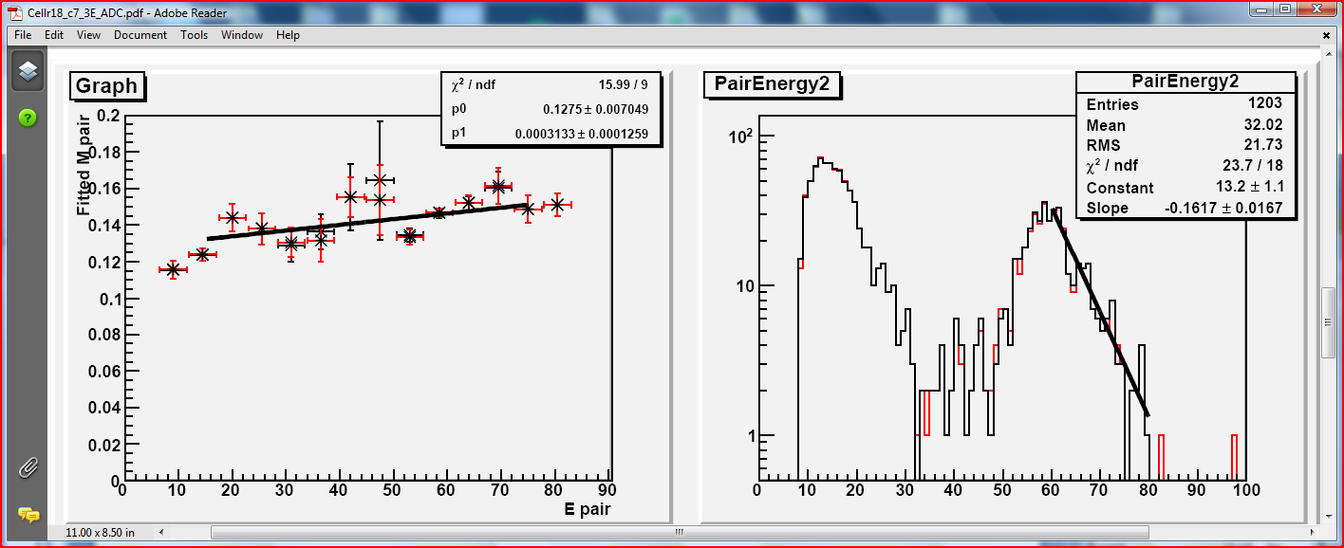

Row-8 Col-9 Small North
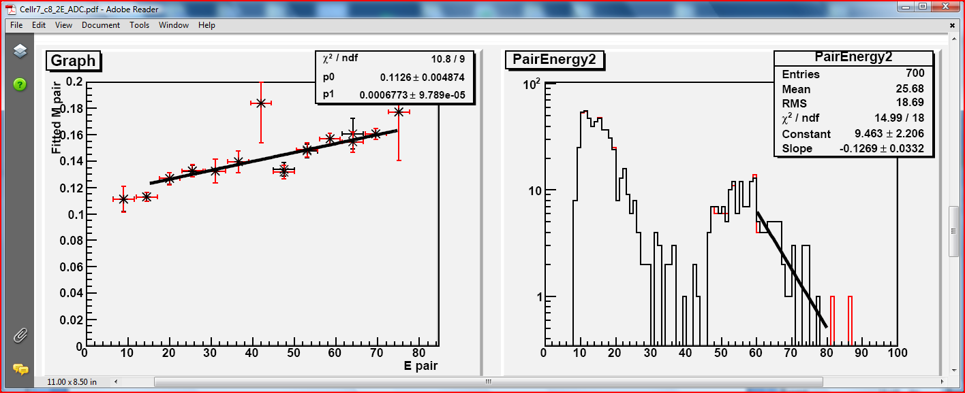
Row-8 Col-9 Small South
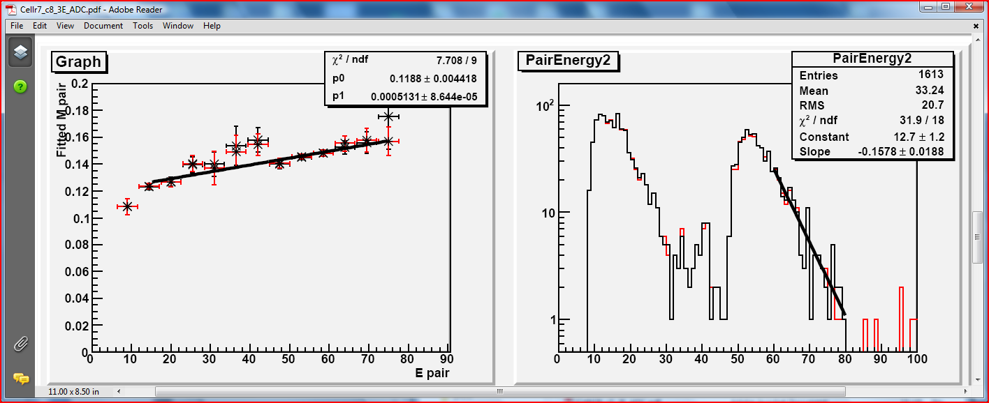

Row-17 Col-9 Small North
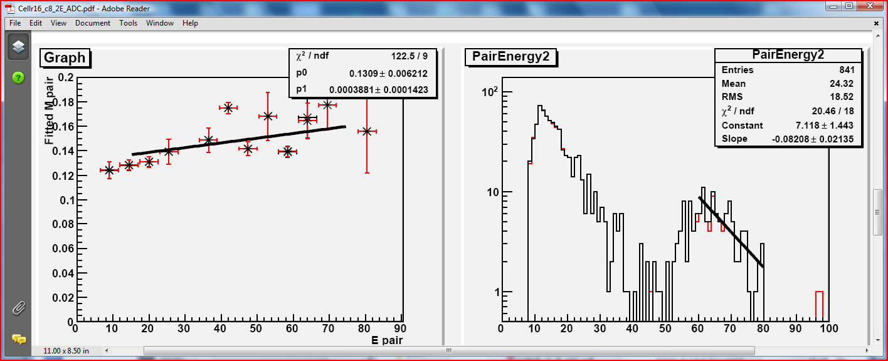
Row-17 Col-9 Small South
